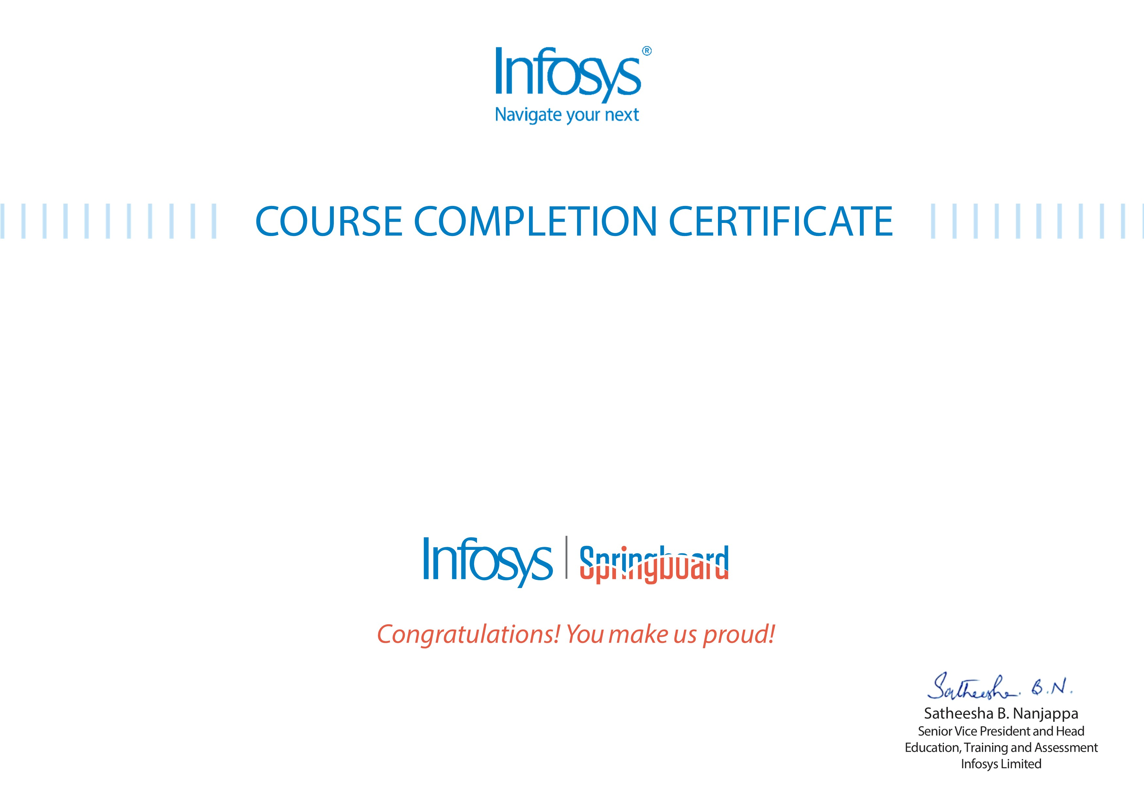
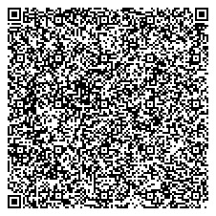
VENNA MAMITHA,CSE 2023 VENNA MAMITHA,CSE 2023

NodeJS Case Study - Movie App on Node JS and MongoDB
The certificate is awarded to
for successfully completing the course
on April 14, 2026
Issued on:
Wednesday, April 15, 2026
To verify, scan the QR code at
htt
ps://verif
y
.onwin
g
span.co
m

